# Exercise 3.1

**Part 1**

|  |  |  |  |
| --- | --- | --- | --- |
| Input | Output | tpd_LH | tpd_HL |
| Low-high | High-low | N/A | 0.07757 ns |
| High-low | Low-high | 0.0907 ns | N/A |

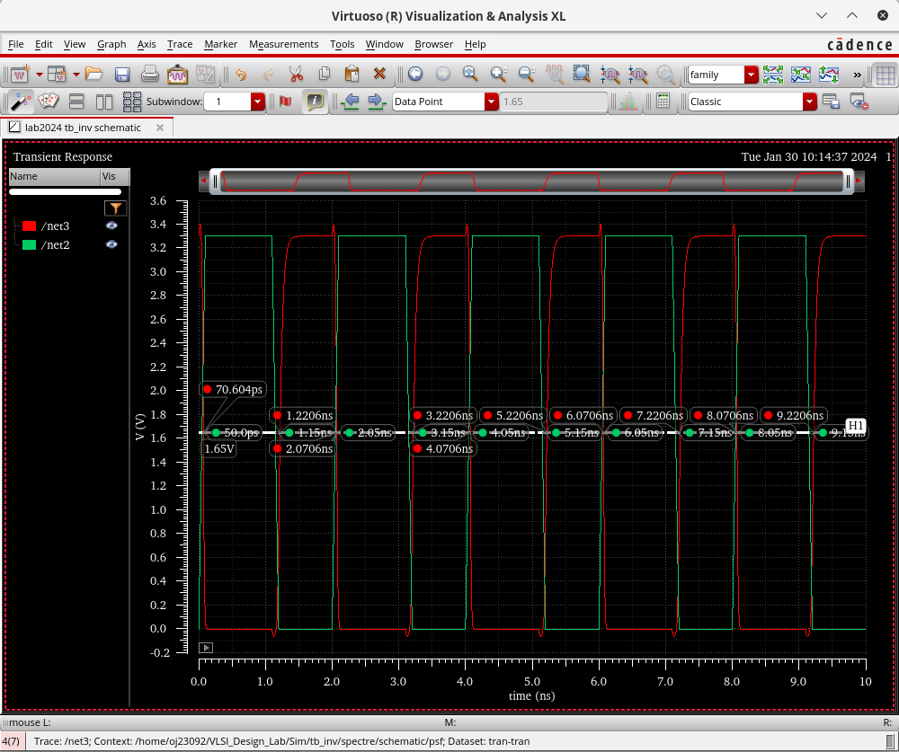

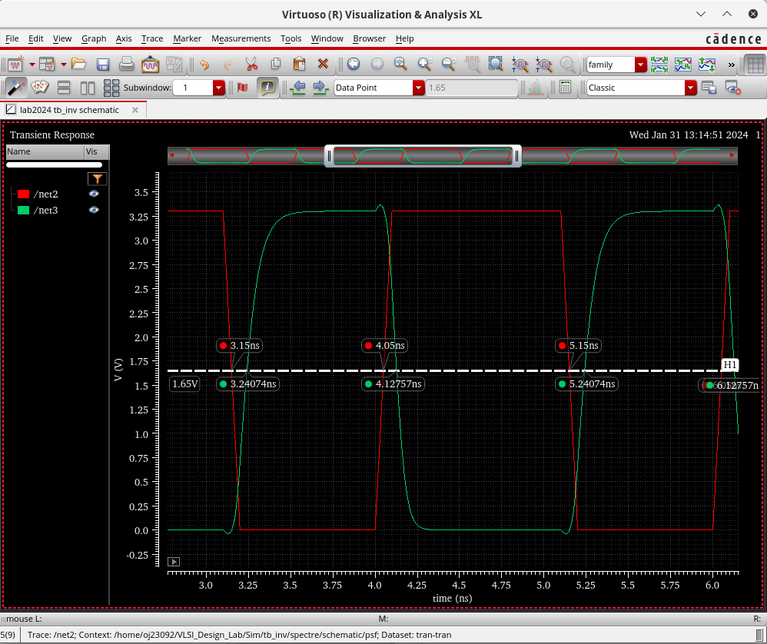

Red is input, and Green is output in the above simulation plot.

**Part 2**

equivalent circuit at the back of ODS notebook

**Part 3**

Derivation: In ODS notebook (back)

tpd_LH = 0.69*Rp*CL

tpd_LH = 0.0907 ns

CL = 12 fF

Rp = 10954.1 Ω

**Part 4**

(Analytic result)

Rp = Rp, min x Wmin/W x L/Lmin

Rp, min = 10954.1 x 1/1 * 0.35/0.35 = 10954.1 Ω = 10.954 kΩ

(After Simulation)

|  |  |  |  |
| --- | --- | --- | --- |
| Input | Output | tpd_LH | tpd_HL |
| Low-high | High-low | N/A | 0.06953 ns |
| High-low | Low-high | 0.15645 ns | N/A |

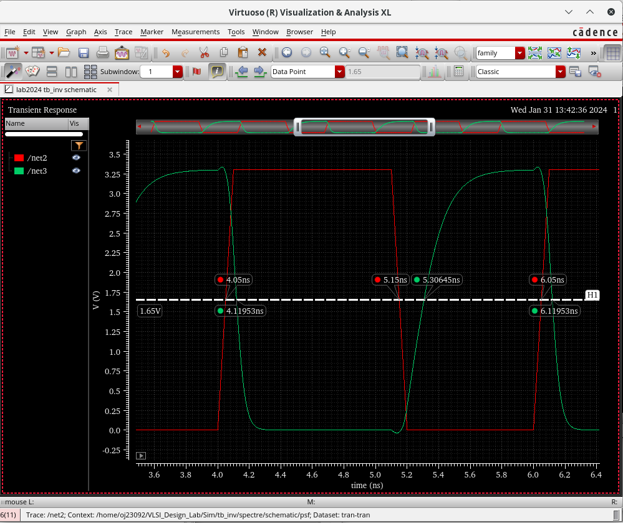

*Output is Green, and Input is Red in the above simulations.*

Rp = 18894.93 Ω = 18.895 kΩ

Rp, min = 18894.93 Ω = 18.895 kΩ

**Part 5**

tpd_HL = 0.69 x Rn x CL

Rn = 9368.36 Ω = 9.368 kΩ

Rn, min = 9368.36 * 1/1 * 0.35*0.35 = 9368.36 Ω = 9.368 kΩ

___

Note: Recheck values of width and length for part 2, 3

# Exercise 3.2

**Part 1**

(See ODS Notebook for derivation values)

PMOS W/L = 3.259/0.35 (mu m)

NMOS W/L = 1.61/0.35 (mu m)

**Part 2**

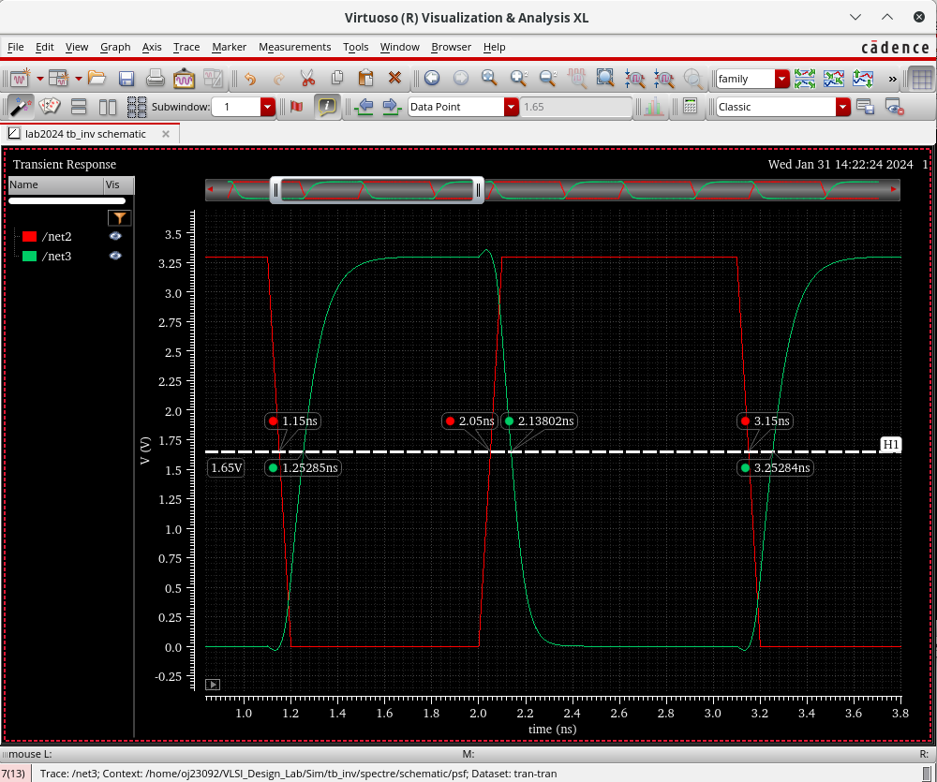

|  |  |  |  |
| --- | --- | --- | --- |
| Input | Output | tpd_LH | tpd_HL |
| Low-high | High-low | N/A | 0.08802 ns = 88.02 ps |
| High-low | Low-high | 0.1028 ns = 102.8 ps | N/A |